Case Study 1 — Employee Salaries
A company records the annual salaries (in ₹ lakhs) of 9 employees:
4, 5, 5, 6, 7, 8, 8, 9, 30
- Find the mean, median, and mode.
- Find the range.
- Calculate the variance and standard deviation.
- Identify the outlier.
- Which measure of central tendency best represents the typical salary? Explain why

Case Study 2 — Website Response Time
A data scientist records the response time (in milliseconds) of a website for 10 requests:
120, 125, 128, 130, 132, 135, 140, 145, 150, 300
- Calculate the mean and median.
- Find the range.
- Calculate the variance and standard deviation.
- Determine whether the data is likely to be right-skewed or left-skewed.
- Explain why the median may be more useful than the mean.

Case Study 3 — Student Performance
The marks of 12 students in a Data Science test are:
42, 45, 48, 50, 52, 52, 55, 58, 60, 62, 65, 95
- Find Q1, Q2 and Q3.
- Calculate the IQR.
- Use the 1.5 × IQR rule to identify any outliers.
- Find the mean and median.
- Explain how the outlier affects the mean.

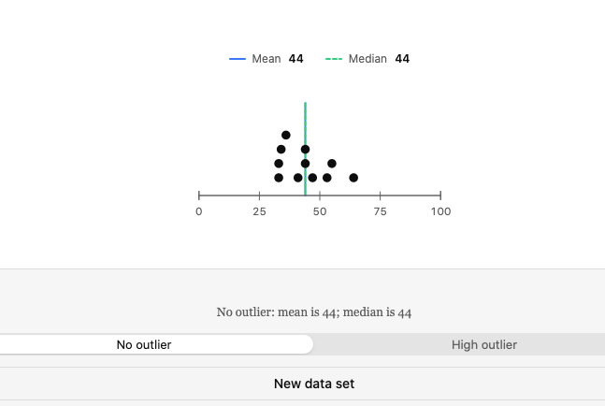

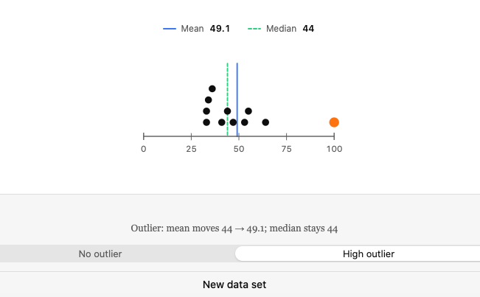

Case Study 4 — E-Commerce Orders
An online store records the number of orders received over 10 days:
18, 20, 22, 22, 24, 25, 26, 28, 30, 35
- Calculate the mean, median, and mode.
- Find the variance and standard deviation.
- Calculate the coefficient of variation if the mean and standard deviation are known.
- What does the standard deviation tell the company?
- Would you describe the order data as highly or moderately variable?

Case Study 5 — Comparing Two Data Science Models
Two machine-learning models have the following prediction errors:
Model A: 2, 3, 3, 4, 4, 5, 5, 6
Model B: 1, 1, 2, 4, 5, 7, 8, 9
- Calculate the mean error for both models.
- Calculate the variance for both models.
- Calculate the standard deviation for both.
- Which model has more consistent predictions?
- Can the model with the lower mean error necessarily be considered better? Explain.

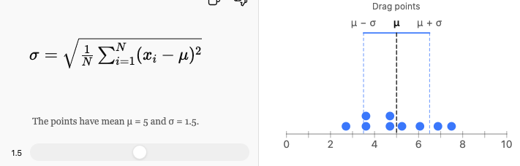

Case Study 6 — Detecting an Unusual Customer
A shopping website finds that the average amount spent by customers is ₹2,000, with a standard deviation of ₹400.
A particular customer spends ₹3,200.
- Calculate the customer's z-score.
- Is the customer's spending unusually high compared with the average?
- What would a negative z-score mean in this context?
- If another customer has a z-score of −1.5, what does it tell you?
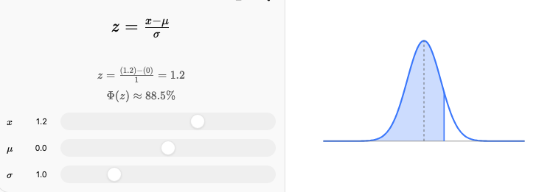

Case Study 7 — Delivery Time Analysis
A delivery company records delivery times (in minutes):
25, 27, 28, 29, 30, 30, 31, 32, 34, 60
- Calculate the mean and median.
- Find Q1 and Q3.
- Calculate the IQR.
- Check for outliers using the 1.5 × IQR rule.
- Explain whether the mean or median gives a better description of the typical delivery time.

Case Study 8 — Two Cities' Temperatures
The average daily temperatures (°C) for 7 days are:
City A: 28, 29, 30, 30, 31, 30, 32
City B: 20, 25, 30, 35, 30, 25, 45
- Calculate the mean temperature for each city.
- Calculate the variance for each city.
- Which city has greater temperature variability?
- Why can two datasets have the same mean but different standard deviations?
- Which city has more predictable temperatures?

Case Study 9 — Data Center CPU Usage
A data scientist records CPU usage percentages:
40, 42, 45, 45, 46, 48, 50, 52, 55, 90
- Calculate mean, median, and mode.
- Calculate the range.
- Find Q1, Q3 and IQR.
- Identify possible outliers.
- Determine the direction of skewness.
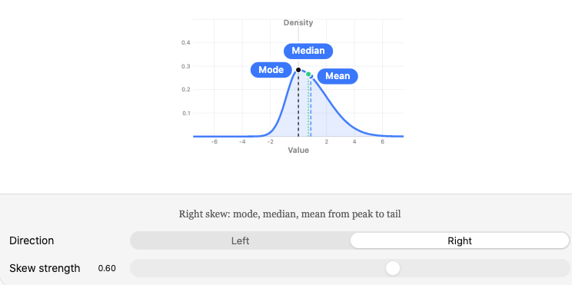

Case Study 10 — Comparing Two Datasets
Two data analysts receive the following datasets:
Dataset A: 10, 20, 30, 40, 50
Dataset B: 28, 29, 30, 31, 32
- Calculate the mean of both datasets.
- Calculate the variance of both.
- Calculate the standard deviation of both.
- Which dataset has greater spread?
- If both datasets represent model errors, which model appears more consistent?
- Explain why mean alone is not enough to compare datasets.
